Ideation Phase
Brainstorm & Idea Prioritization Template

Date | 27 FEB 2026
Team ID | LTVIP2026TMIDS41352
Project Name | ShopEZ:One-Stop Shop for Online Purchases
Maximum Marks | 4 Marks

Brainstorm & Idea Prioritization Template:
To initiate the development of ShopEZ, our team conducted a structured brainstorming session to identify real-world problems in existing e-commerce platforms. The objective was to understand gaps in current systems and define a clear problem statement.
We gathered as a team and encouraged open discussion where every member contributed ideas without judgment. The session focused on identifying pain points faced by both customers and sellers.
Problems Identified:
- Complicated and cluttered user interfaces
- Time-consuming checkout processes
- Lack of personalized recommendations
- Poor seller-side analytics and order management
- Limited filtering and search capabilities
- Security concerns in online transactions
After evaluating these challenges, we finalized the following problem statement:
“To design and develop a user-friendly, secure, and efficient full-stack e-commerce platform that enhances product discovery, simplifies checkout, and provides powerful tools for sellers.”
Reference: https://github.com/sridinesh04/MERNSTACK-_SHOPEZ-SHOP-TO-STOP-.git
Step-1: Team Gathering, Collaboration and Select the Problem Statement

Problems Identified:
- Complicated and cluttered user interfaces
- Time-consuming checkout processes
- Lack of personalized recommendations
- Poor seller-side analytics and order management
- Limited filtering and search capabilities
- Security concerns in online transactions
After evaluating these challenges, we finalized the following problem statement:
“To design and develop a user-friendly, secure, and efficient full-stack e-commerce platform that enhances product discovery, simplifies checkout, and provides powerful tools for sellers.”
This defined the foundation for ShopEZ.

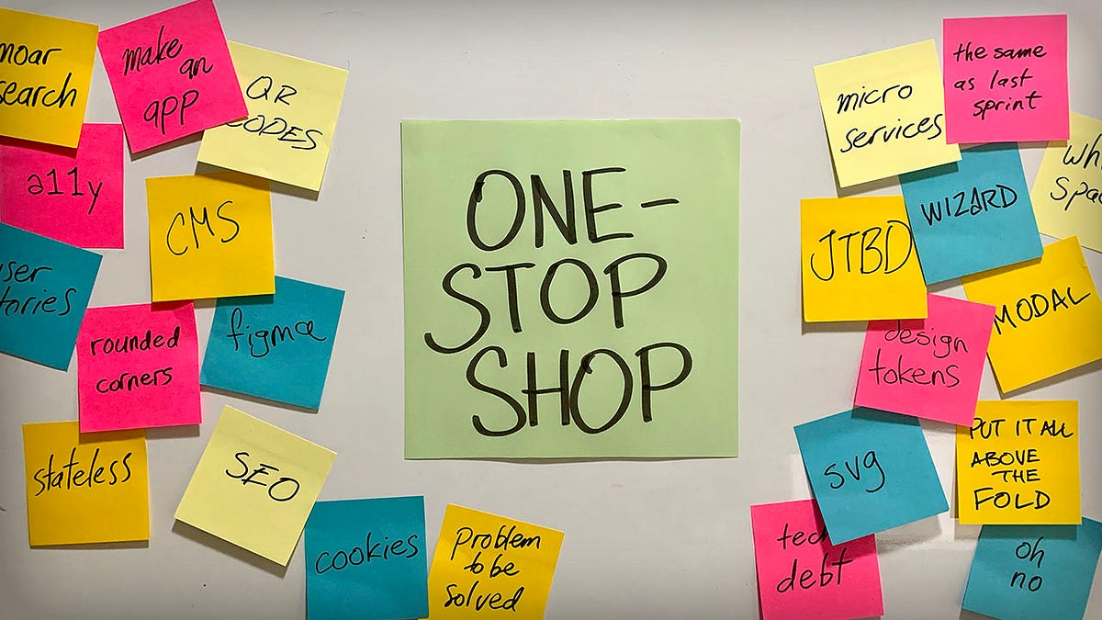

Step-2: Brainstorm, Idea Listing and Grouping
In the second phase, we generated a large number of ideas without restricting creativity. The goal was to maximize idea generation before filtering them.
Ideas Generated:
- Smart product filtering (category, price, rating)
- Personalized product recommendations
- Wishlist feature
- Cart auto-save functionality
- One-click checkout system
- Secure authentication with JWT
- Role-based access (User/Admin)
- Seller dashboard for order tracking
- Sales analytics for sellers
- Discount coupon system
- Email notifications for orders
- Product reviews and ratings
- Responsive design for mobile users
- Inventory management system
After listing all ideas, we grouped them into logical categories:
User Experience Enhancements:
- Smart search and filtering
- Personalized recommendations
- Wishlist
- Reviews and ratings
- Responsive UI
Checkout & Payment Improvements:
- One-click checkout
- Secure transaction handling
- Cart management
- Coupon system
Seller & Admin Management:
- Seller dashboard
- Order processing system
- Inventory control
- Sales analytics
- Role-based authentication
Security & System Stability:
- Password encryption
- JWT authentication
- Protected routes
- Secure API handling
This grouping helped us understand the system structure clearly and divide development tasks efficiently.

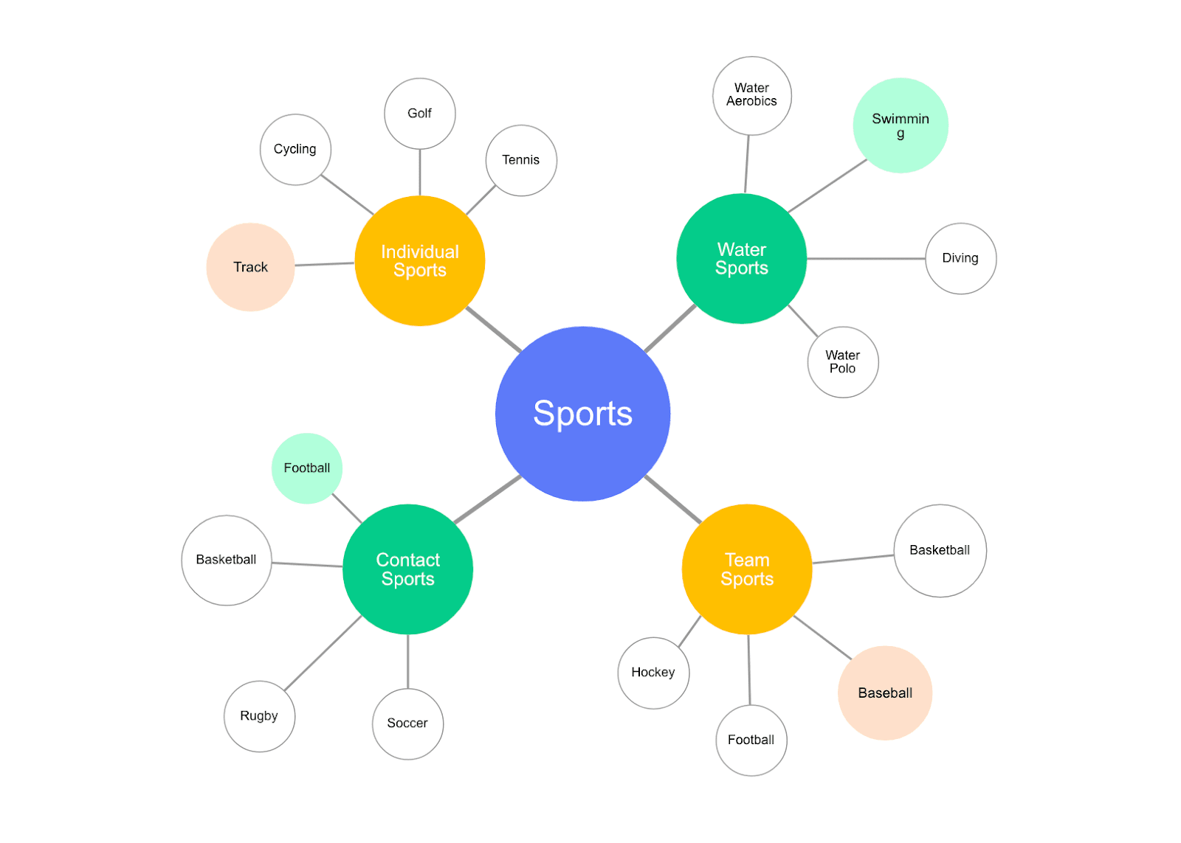

Step-3: Idea Prioritization
After brainstorming, we prioritized ideas using an Impact vs Feasibility approach. The goal was to implement high-impact and highly feasible features first.
High Impact & High Feasibility (Must-Have Features):
- User Authentication System
- Product Listing & Filtering
- Add to Cart & Cart Management
- Checkout Process
- Order Management System
- Admin Dashboard
These were implemented as core features of ShopEZ.
Medium Priority Features:
- Product Reviews & Ratings
- Sales Analytics Dashboard
- Discount Coupons
Future Enhancements:
- AI-based Personalized Recommendations
- Advanced Seller Analytics
- Payment Gateway Integration (Stripe/Razorpay)
- Chatbot Assistance
By prioritizing features systematically, we ensured timely development and effective resource utilization.
